**Project Report On**

Online Job Portal

**Submitted By**

Mihir P. Makwana (Seat No. : 6115118)

# Submitted for

Project Work

BCA Semester - VI (2022-23)

# Submitted To



**S.G.M. English Medium College of Commerce and Management (SEMCOM)**

**CVM University**

# The Charutar Vidya Mandal University

# S.G.M. English Medium College of Commerce and Management

**(SEMCOM)**

**Vallabh Vidyanagar**

**CERTIFICATE**

**Date: 02/05/2023** .

This is to certify that **Mihir P. Makwana** of BCA – SEM - VI **(Seat No. 6115118)** has worked on project entitled **Online Job Portal** from **20/12/2022** to **7/4/2023**. This **(**101150606**)** is an in-house project course of nine credits.

He / She was regular in his work and developed the project including analysis and design. He / She has completed the project satisfactorily.

**Principal Project Guide**

#### **Principal Project Guide**



**2022-23**

**Project Work**

**6115118**

**TYBCA - VI**

**02/05/2023**

**____**

**____**

**____**

**Mihir P. Makwana**

**Acknowledgement**

"I express my heartfelt gratitude to all those who helped and supported me in the successful completion of this project.

Special thanks to my advisors, Professor **Ms. Palak Patel** Madam and **Mr. Abhishek Dave** Sir, for providing valuable guidance and constructive feedback throughout the project. I am also grateful to the college faculty for giving me the opportunity to work on this project and for providing the necessary resources.

I would also like to extend my thanks to my colleagues and friends for their support and encouragement during the course of the project.

Last but not least, I acknowledge the immense contribution of the internet and various online resources, without which this project would not have been possible.

Once again, I express my sincere gratitude to all those who supported me in making this project a success."

**Index**

|  |  |  |
| --- | --- | --- |
| **Sr.**  **No.** | **Description of Topic** | **Page No.** |
| **1** | Title Page of Project | 1 |
| **2** | College Certificate | 2 |
| **3** | Acknowledgement | 4 |
| **4** | Index | 5 |
| **5** | Project Profile | 6 |
| **6** | An Existing System | 10 |
| **7** | Hardware and Software | 11 |
| **8** | Data Flow Diagram | 12 |
| **9** | Database Layout | 17 |
| **10** | Screens | 22 |
| **11** | Limitations | 32 |
| **12** | Conclusion | 32 |
| **13** | Bibliography | 33 |

**Project Profile**

**Introduction:**

**Project Title:** Online Job Portal

**Project Goals:**

* To provide a platform for job seekers and employers to connect and find suitable job opportunities.
* To streamline the job search and application process for job seekers.
* To help employers easily find qualified job applicants.

**Project Objectives:**

* To create a user-friendly website for job seekers and employers to use.
* To develop a database to store job listings and job seeker profiles.
* To implement an efficient search algorithm to match job seekers with suitable job openings.
* To provide secure user registration and login for job seekers and employers.
* To allow employers to send notifications to job seekers regarding the selection process.

**Project Scope:**

* The job portal will be a web-based platform accessible through a web browser.
* Job seekers will be able to create a profile, upload their resume, and apply for jobs.
* Employers will be able to post job listings, search for suitable job seekers, and view job applications.
* Employers will also be able to send notifications to job seekers regarding the selection process.
* The job portal will be developed using Java, JSP, HTML, and CSS.

**Expected Outcomes:**

* A functional job portal that meets the needs of both job seekers and employers.
* An efficient and effective platform for job seekers to find suitable job opportunities and for employers to find qualified candidates.
* Improved user experience for both job seekers and employers.
* Improved communication between employers and job seekers regarding the selection process.

**The modules involved are:**

* Admin
* Job Seeker
* Job Provider
* Search
* Registration

Admin: In this module Admin will add all the qualifications, skill, experience, city, state, country and update and delete information about the job provider or job seeker he can also search for the job seeker and he can send mail to offer the job to job seeker and he can also see the jobs add by the job provider.

Job Seeker: In this module Job Seeker register himself and upload his resume and fill the profile give by admin and after login he will search for the job on various conditions and he can change his profiles and resume and he can apply for the jobs based on various conditions. He can see the response of the company and he can call the company person for the interview.

Employer: In this module Employer register himself and his company and after login he will add new job and he can search for the job seekers on various condition and he can offer the job to job seeker according to the job profile and he can also see the response from the job seekers and send the mail.

Search: This module will allow job seekers to search for jobs based on various conditions such as job title, location, industry, job type, etc. and will display the results based on the search criteria. Additionally, the job provider will be able to search for job seekers based on their qualifications, skills, experience, location, etc. and offer them the job accordingly. The Search module will be integrated with the Job Seeker, Job Provider, modules to ensure seamless communication between them.

Registration: The registration module allows job seekers and job providers to create their accounts on the online job portal. Job seekers can provide their personal information, educational qualifications, work experience, and upload their resumes. Job providers can register their company and provide company details. The module ensures the authenticity of the user by verifying their email address and mobile number. Once registered, users can log in to their accounts to access the services provided by the online job portal.

**Features:**

1. **User-friendly interface:** A visually appealing and intuitive user interface designed for both job seekers and employers to use.
2. **Job Listings database:** A database to store job listings and job seeker profiles, allowing job seekers to easily find suitable job opportunities and employers to find potential candidates.
3. **Efficient search algorithm:** An algorithm to match job seekers with suitable job openings based on their skills, experience, and preferences.
4. **Secure user registration and login:** A secure system for user registration and login to ensure the privacy and security of users' personal and professional information.
5. **Employer notifications:** The ability for employers to send notifications to job seekers regarding the selection process, keeping both parties informed and engaged.
6. **Platform independence:** The use of Java and JSP allows for platform independence, making the website accessible from any device with an internet connection.
7. **Encrypted passwords:** Passwords are encrypted to ensure the security of users' accounts and protect their personal and professional information.
8. **Scalability:** The system is designed to be scalable to accommodate an increasing number of users and job listings, ensuring a smooth user experience even as the system grows.
9. **Future developments:** Potential future developments, such as resume building and management, advanced search filters, and a mobile application, will be considered to enhance the user experience and expand the capabilities of the Job Portal.

**Scope of Work:**

1. Objectives

* To provide a platform for job seekers to search for job listings and apply for positions
* To provide a platform for employers to post job listings and manage applicants
* To create a user-friendly interface for both job seekers and employers

1. Deliverables

* A fully functional job portal website with a user-friendly interface
* A database for storing job listings and applicant information
* A system for job seekers to search for job listings and apply for positions
* A system for employers to post job listings and manage applicants

1. Timeline

* Start Date: December 20, 2022
* End Date: April 07, 2023

**Key Milestones:**

1. Completion of website design and user interface development by January 31, 2023
2. Completion of database development and integration by February 28, 2023
3. Completion of job seeker and employer functionality by March 31, 2023
4. Final testing and deployment by April 07, 2023

Testing and Deployment:

Once the development of the job portal is complete, a rigorous testing process will be undertaken to ensure that the system is functioning as intended. The testing process will involve identifying and fixing any bugs, ensuring that the user interface is intuitive and easy to use, and verifying that the system meets the project goals and objectives. Once testing is complete, the system will be deployed to the production environment to make it available to users. This deployment will be carefully planned and executed to minimize any potential downtime or disruptions to users.

**Needs of the Project:**

1. **User-Friendly Interface:** To create a user-friendly website that is easy to navigate and use for job seekers and employers.
2. **Efficient Search Algorithm:** To develop an efficient search algorithm that matches job seekers with suitable job openings.
3. **Secure User Registration and Login:** To provide secure user registration and login for job seekers and employers.
4. **Database for Job Listings and Job Seeker Profiles:** To develop a database to store job listings and job seeker profiles.
5. **Employer Notifications:** To allow employers to send notifications to job seekers regarding the selection process.
6. **Fast Load Times and Efficient Resource Use:** To optimize the website for fast load times and efficient use of resources to ensure a smooth user experience.
7. **Scalability:** To make the system scalable to accommodate an increasing number of users and job listings.

**Conclusion:**

The Job Portal project is designed to address the needs of both job seekers and employers. By providing a user-friendly interface, an efficient search algorithm, and secure user registration and login, the project will provide added value to its users. The project will also store job listings and job seeker profiles in a database and allow employers to send notifications to job seekers regarding the selection process. These features are not available in existing job portals and will provide a unique solution to the job search process.

**An Existing System**

The current job portals in the market are either job search engines or company-specific career websites. However, these portals have several limitations, including:

1. **Limited job listings**: The current job portals offer a limited number of job listings, which do not provide a comprehensive list of job opportunities.
2. **Lack of interaction between job seekers and employers**: The existing systems do not provide a platform for job seekers and employers to interact and find suitable job opportunities.
3. **Poor user interface**: The current job portals lack a user-friendly interface, making it difficult for users to navigate and use the website effectively.
4. **Inefficient search algorithms**: The existing systems do not have efficient search algorithms to match job seekers with suitable job openings.
5. **Insecure user registration and login**: The current job portals do not provide secure user registration and login, putting the users' personal and sensitive information at risk.

The proposed job portal aims to address these limitations by providing a platform for job seekers and employers to connect and find suitable job opportunities. The job portal will offer the following features:

1. **User-friendly interface**: The job portal will have a user-friendly interface, making it easy for job seekers and employers to use the portal effectively.
2. **Efficient search algorithm**: The job portal will use an efficient search algorithm to match job seekers with suitable job openings.
3. **Secure user registration and login**: The job portal will provide secure user registration and login, ensuring the privacy and security of users' personal and sensitive information.
4. **Database to store job listings and job seeker profiles**: The job portal will store job listings and job seeker profiles in a database, providing a comprehensive list of job opportunities.
5. **Notification system for employers**: Employers will be able to send notifications to job seekers regarding the selection process.

The proposed job portal will offer additional benefits not found in the current job portals, providing added value to job seekers and employers.

**Hardware and Software**

**Hardware Specifications:**

* Processor: Pentium 4 (Dual Core)
* RAM: 256 MB
* HDD: 1.2 GB Hard Disk Space
* Monitor: VGA/SVGA Colour
* Mouse: Any Normal Mouse
* Keyboard: Any Windows Supported Keyboard

**Software Specifications:**

Software consists of sets of instructions that mold the raw arithmetic and logical capabilities of the hardware units to perform specific tasks. The following software tools have been used to finalize the project, which are the basic requirements for the Online Job Portal project:

* **JDK 1.8**
* **Programming Language: JAVA, JDBC**
* **Web Tools: JSP, SERVLET, JDBC, HTML, CSS.**
* **Web Server: Apache Tomcat 9.0**
* **RDBMS: MySQL**
* **Operating System: MS Windows 7/8/10/11**

**Data Flow Diagram**

**Process Hierarchy:**

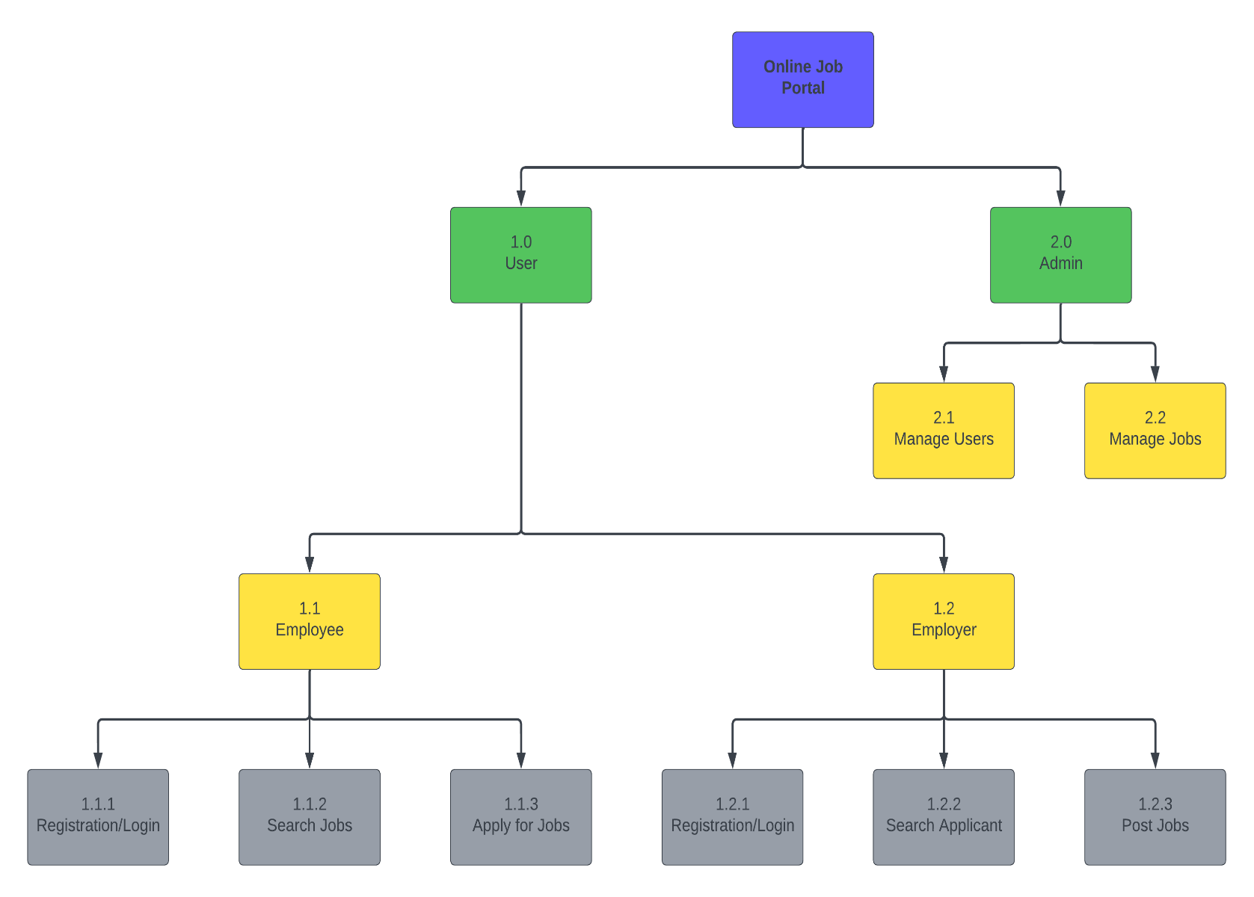

**Context Level DFD:**

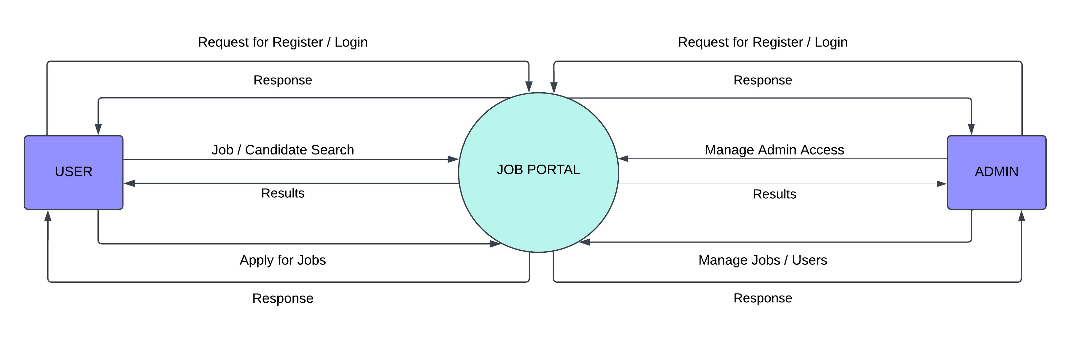

**Zero - Level DFDs:**

**DFD of Employer:**

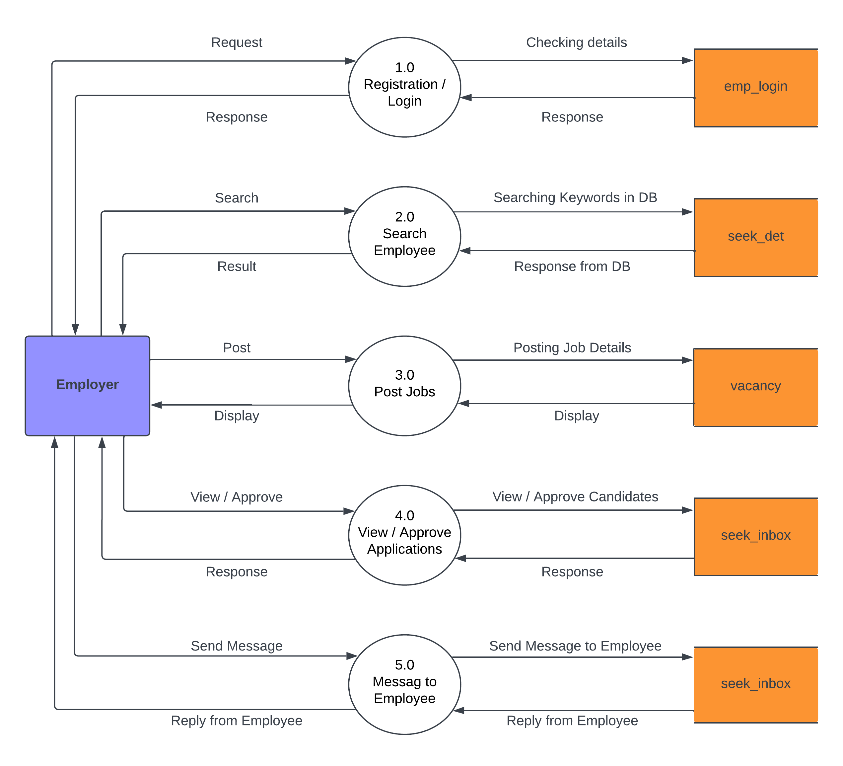

**DFD for Job Seeker/Employee:**

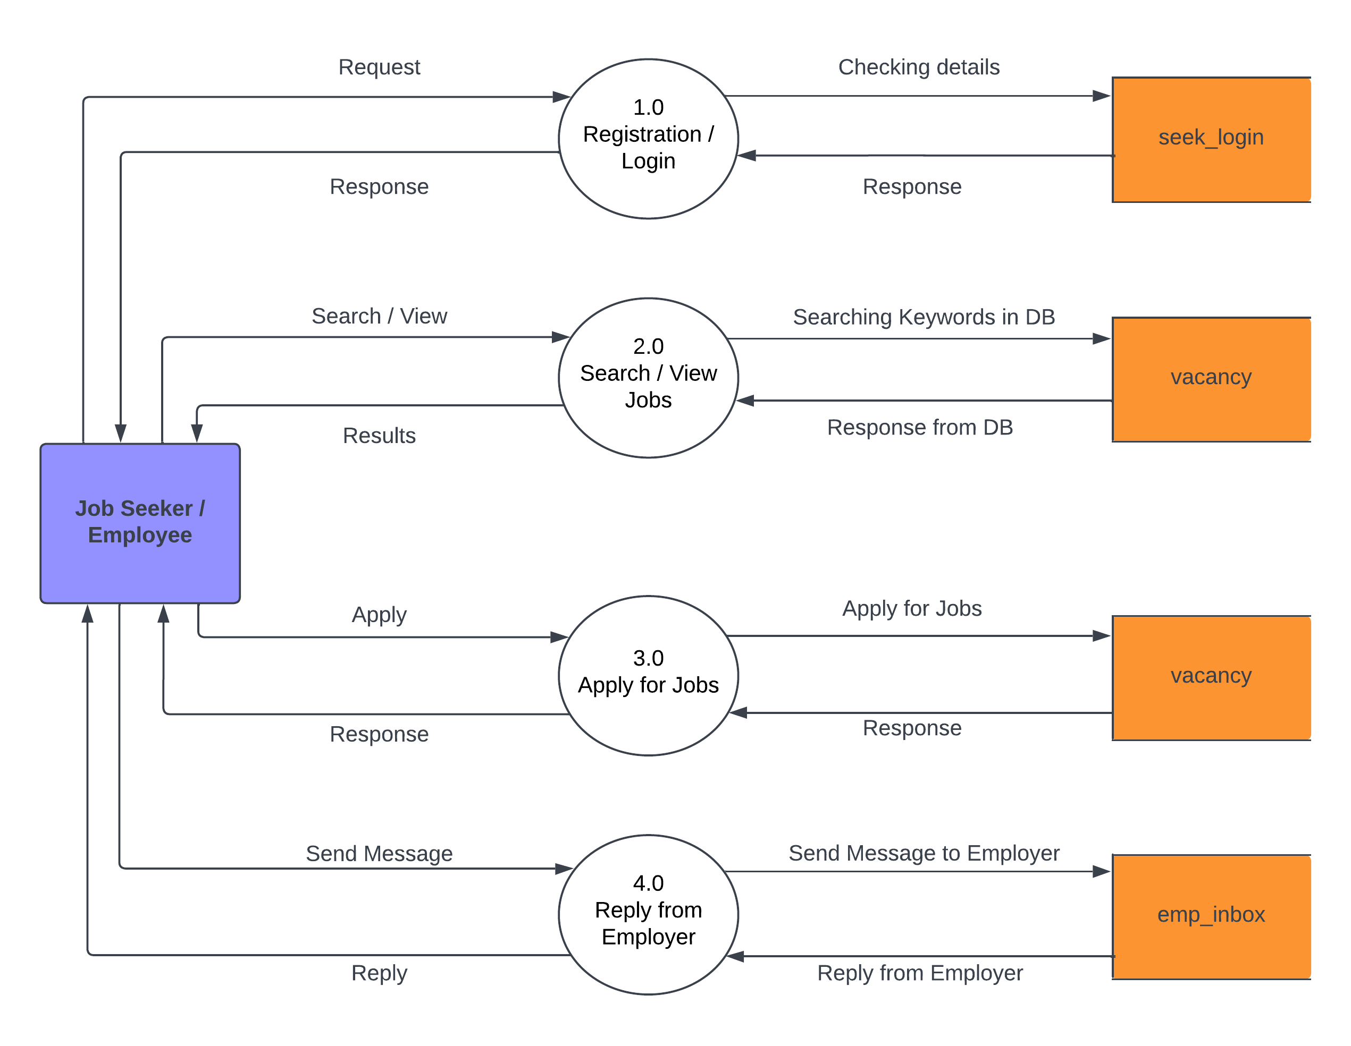

**DFD for Admin:**

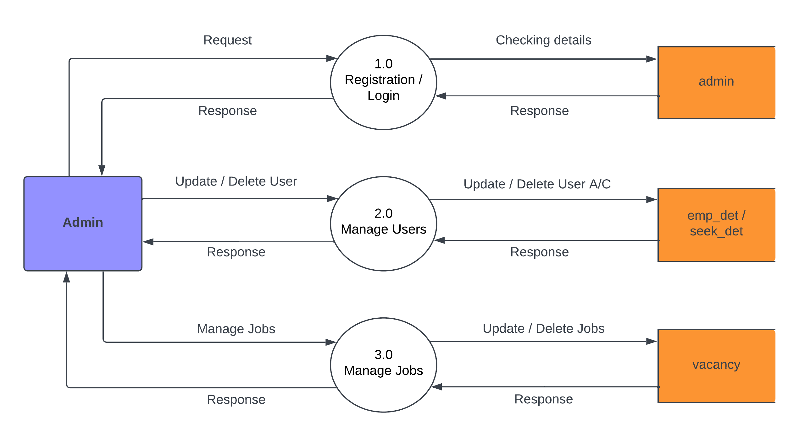

**Database Layout:**

**Admin Table:**

|  |  |  |  |
| --- | --- | --- | --- |
| **Field Name** | **Data Type** | **Null** | **Key** |
| u_id | Varchar(10) | Not null | Primary key |
| pwd | Varchar(20) | Not null |  |

The Admin Table contains information about the administrators of a system. It displays data for two fields: u_id, which represents the administrator's ID and is the primary key, and pwd, which represents the administrator's password. Both fields are of the Varchar data type, and u_id cannot be null.

**Admin_Det:**

|  |  |  |  |
| --- | --- | --- | --- |
| **Field Name** | **Data Type** | **Null** | **Key** |
| u_id | Varchar(10) | Not null | Primary key |
| fname | Varchar(15) | Not null |  |
| lname | Varchar(15) | Not null |  |
| phone | bigint(10) | Not null |  |
| country | Varchar(15) | Not null |  |
| city | Varchar(15) | Not null |  |
| doa | date | Not null |  |

The "Admin_Det" table provides details of the administrator, including their unique ID, first name, last name, phone number, country, city, and date of admission. The "u_id" field serves as the primary key for this table, ensuring that each administrator has a unique record.

**Seek_Det Table:**

|  |  |  |  |
| --- | --- | --- | --- |
| **Field Name** | **Data Type** | **Null** | **Key** |
| j_id | Varchar(15) | Not null | Primary key |
| email | Varchar(30) | Not null |  |
| f_name | Varchar(15) | Not null |  |
| l_name | Varchar(15) | Not null |  |
| phone_no | bigint(10) | Not null |  |
| q_id | Varchar(10) | Not null |  |
| skills | Varchar(20) | Not null |  |
| city | Varchar(15) | Not null |  |
| country | Varchar(15) | Not null |  |
| doreq | date | Not null |  |

The Seek_Det table contains details of job seekers, including their ID, name, contact information, qualifications, skills, and location. The table also includes the date when the job seeker submitted their details.

**Experience Table:**

This gives the experience of all the job-seekers.

|  |  |  |  |
| --- | --- | --- | --- |
| **Field Name** | **Data Type** | **Null** | **Key** |
| j_id | varchar(10) | not null | Primary key |
| job_cat | varchar(10) | Not null |  |
| months | Int(2) | Not null |  |
| f_name | varchar(15) | Not null |  |
| l_name | varchar(15) | Not null |  |
| skills | varchar(20) | Not null |  |
| city | varchar(15) | Not null |  |
| country | varchar(15) | Not null |  |
| email | varchar(30) | Not null |  |

The Experience Table records the work experience of job seekers, including job category, number of months worked, first and last name, skills, city, country, and email. The j_id field is the primary key, ensuring unique identification for each job seeker.

**Seek_Login Table:**

It stores the login id and password of the job seeker.

|  |  |  |  |
| --- | --- | --- | --- |
| **Field Name** | **Data Type** | **Null** | **Key** |
| j_id | Varchar(10) | Not null | Primary key |
| pwd | Varchar(20) | Not null |  |

The Seek_Login table stores the login credentials of job seekers, including their login ID and password. The j_id field is the primary key, and the table does not allow null values for this field. The password field can also not be null and can hold up to 20 characters.

**Seek_Inbox Table:**

It maintains the inbox of the job-seeker.

|  |  |  |  |
| --- | --- | --- | --- |
| **Field Name** | **Data Type** | **Null** | **Key** |
| j_id | Varchar(10) | Not null | Primary key |
| f_name | Varchar(15) | Not null |  |
| email | Varchar(30) | Not null |  |
| e_id | Varchar(10) | Not null |  |
| emp_email | Varchar(30) | Not null |  |

The Seek_Inbox table stores job-seeker information and maintains their inbox. It includes fields for the job-seeker's ID, first name, email, employer ID, and employer email. The j_id field serves as the primary key for this table.

**Emp_Det Table:**

This gives the information of all the employers.

|  |  |  |  |
| --- | --- | --- | --- |
| **Field Name** | **Data Type** | **Null** | **Key** |
| e_id | Varchar(10) | Not null | Primary key |
| email | Varchar(30) | Not null |  |
| fname | Varchar(20) | Not null |  |
| lname | Varchar(20) | Not null |  |
| phone | bigint(10) | Not null |  |
| address | Varchar(255) | Not null |  |
| dor | date | Not null |  |

The Emp_Det table provides information on all the employers and includes fields for employee ID, email, first name, last name, phone number, address, and date of registration. The primary key is the e_id field.

**Company Table:**

This stores the details of the company and their location.

|  |  |  |  |
| --- | --- | --- | --- |
| **Field Name** | **Data Type** | **Null** | **Key** |
| reg_no | Int(11) | Not null | Primary key |
| e_id | Varchar(10) | Not null |  |
| c_name | Varchar(10) | Not null |  |
| addr1 | Varchar(255) | Not null |  |
| country | Varchar(15) | Not null |  |
| city | Varchar(15) | Not null |  |

The Company Table contains information about registered companies and their locations. It stores data such as the registration number, company name, address, country, and city. The registration number serves as the primary key while the e_id, which is a unique identifier for each company, and other fields are mandatory and cannot be left blank.

**Vacancy Table:**

This shows the number of vacancies available and their details.

|  |  |  |  |
| --- | --- | --- | --- |
| **Field Name** | **Data Type** | **Null** | **Key** |
| job_id | Int(11) | Not null | Primary key |
| c_name | Varchar(30) | Not null |  |
| e_id | Varchar(10) | Not null |  |
| job_cat | Varchar(10) | Not null |  |
| no_vac | Int(3) | Not null |  |
| q_id | Varchar(10) | Not null |  |
| req | Varchar(30) | Not null |  |
| addr1 | Varchar(255) | Not null |  |
| city | Varchar(15) | Not null |  |
| country | Varchar(15) | Not null |  |
| skills | Varchar(30) | Not null |  |
| email | Varchar(30) | Not null |  |

The Vacancy Table contains information about the number of available job vacancies and their details. It includes the job ID, company name, employer ID, job category, number of vacancies, qualification ID, job requirements, address details, city, country, required skills, and email address.

**Emp_Login Table:**

It stores the login id and password of the employer.

|  |  |  |  |
| --- | --- | --- | --- |
| **Field Name** | **Data Type** | **Null** | **Key** |
| e_id | Varchar(10) | Not null | Primary key |
| password | Varchar(20) | Not null |  |

The Emp_Login table contains login credentials for employers, storing their login ID and password. The e_id field is the primary key and stores the login ID as a string of up to 10 characters, while the password field stores passwords up to 20 characters long.

**Emp_Inbox Table:**

It stores the employer inbox mail.

|  |  |  |  |
| --- | --- | --- | --- |
| **Field Name** | **Data Type** | **Null** | **Key** |
| e_id | Varchar(10) | Not null | Primary key |
| f_name | Varchar(15) | Not null |  |
| email | Varchar(25) | Not null |  |
| j_id | Varchar(10) | Not null |  |
| seek_email | Varchar(25) | Not null |  |

The Emp_Inbox table is used to store employer inbox mail information for the Online Job Portal project. It contains fields for employer ID, first name, email, job ID, and seeker email. The e_id field is the primary key of this table.

**Jobs_Applied Table:**

It stores the employer inbox mail.

|  |  |  |  |
| --- | --- | --- | --- |
| **Field Name** | **Data Type** | **Null** | **Key** |
| appl_id | int(5) | Not null | Primary key |
| job_id | Varchar(5) | Not null |  |
| j_id | Varchar(30) | Not null |  |
| status | Varchar(30) | Not null |  |

The Jobs_Applied table stores information about job applications, including the application ID, job ID, employer ID, and status of the application. The table serves as the employer inbox mail, where they can view and manage applications received from job seekers. The table's primary key is the appl_id field, which uniquely identifies each application.

**Screens**

**Online Job Portal:** This is the index page of the Online Job Portal, which provides an overview of the portal's features and includes hyperlinks to the Employee and Employer Register, Search, and Admin pages.

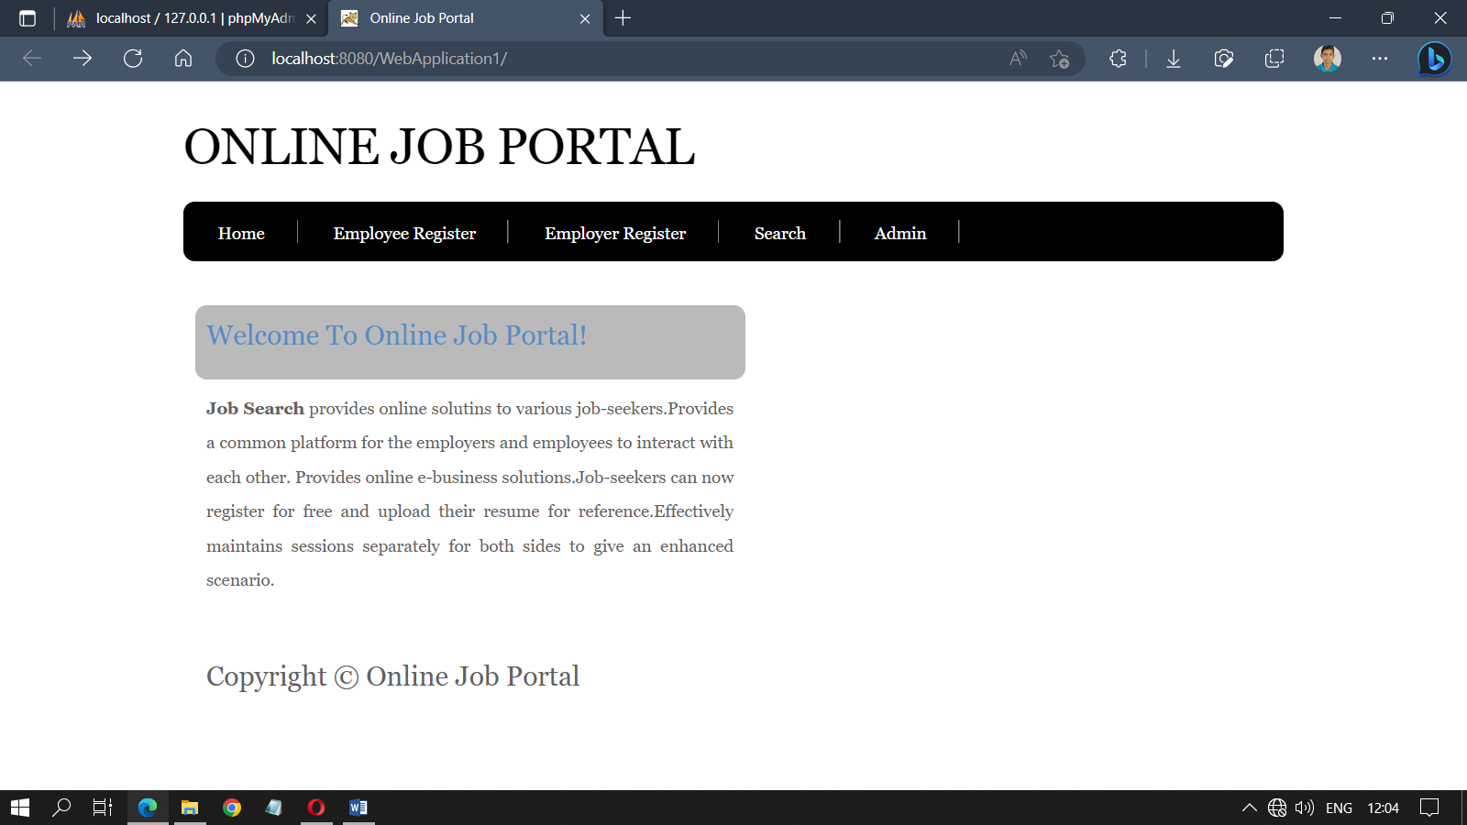

**Home Page:** This is the Home page of the Online Job Portal, which provides a search jobs section, an Employer and Employee Registration section, and filter-wise searching by category, location, and type of job.

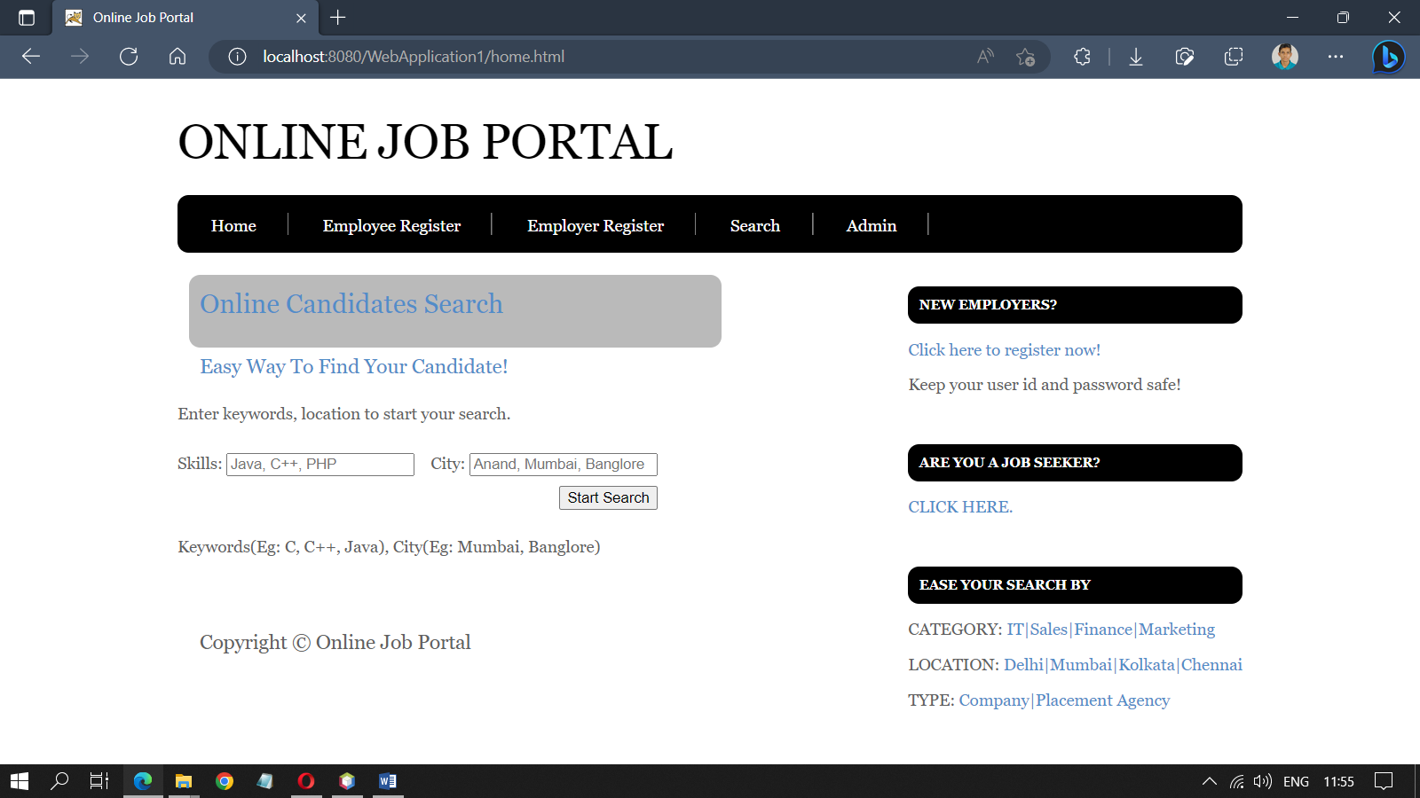

**Job Seeker / Employee:** This is the Employee/Job Seeker page of the online job portal, which includes a registration form and a login form for job seekers/employees.

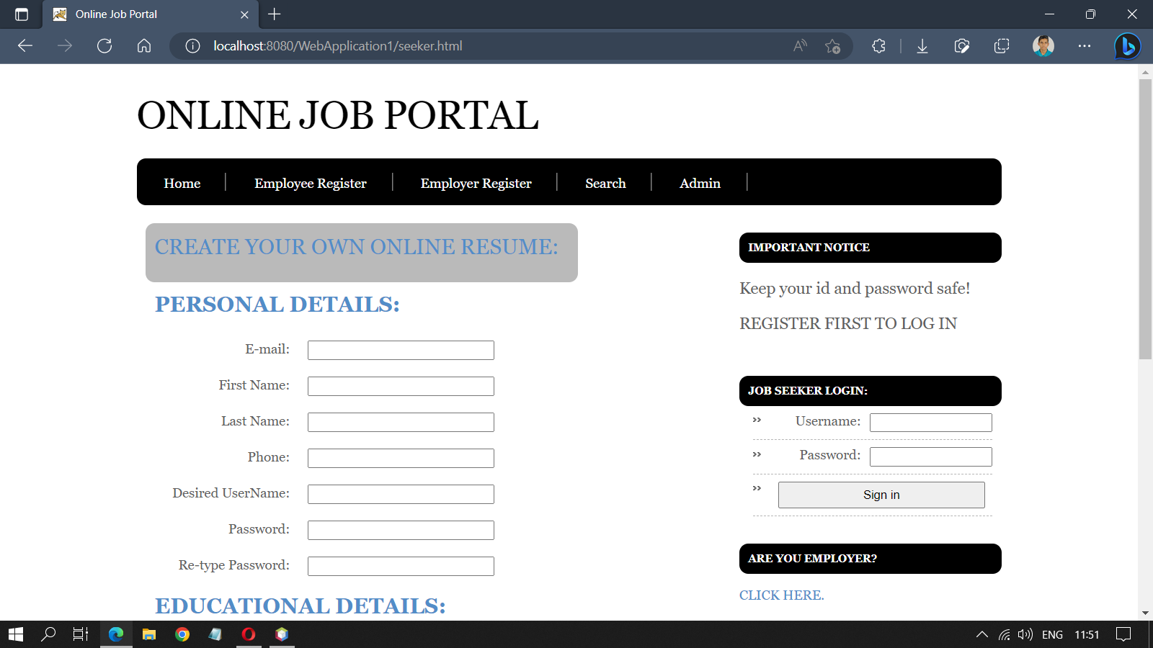

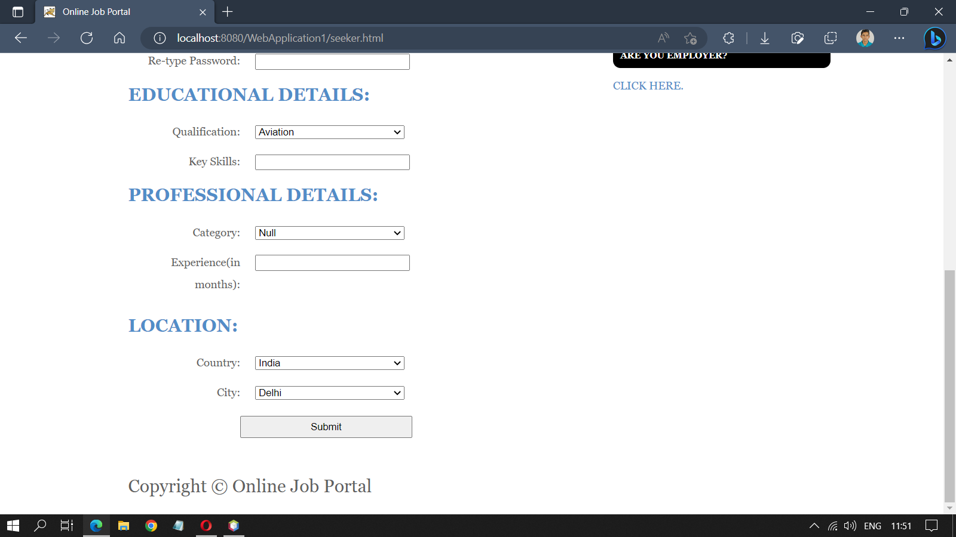

**Employer:** This is the Employer page of the Online Job Portal. The page includes the registration and login form for Employers.

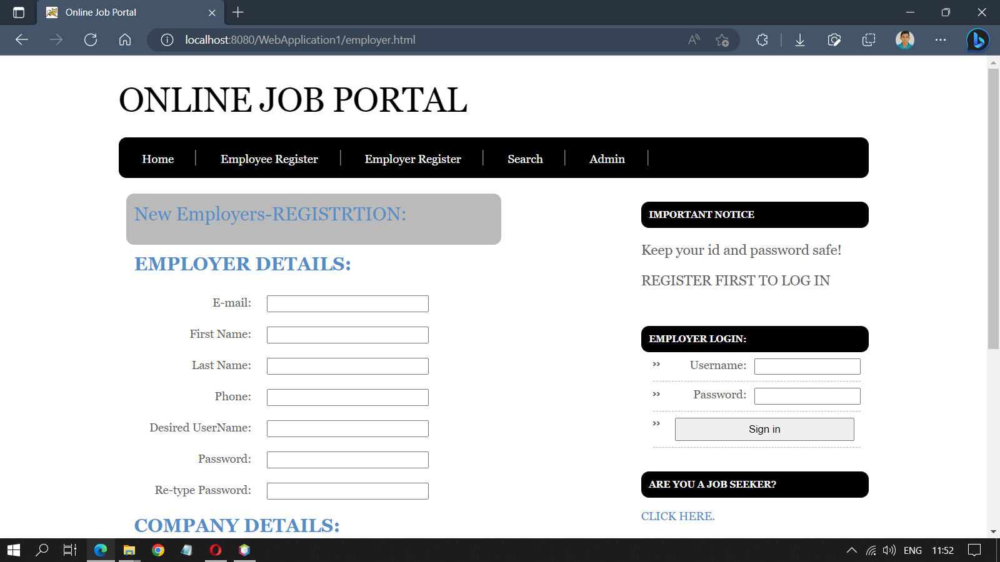

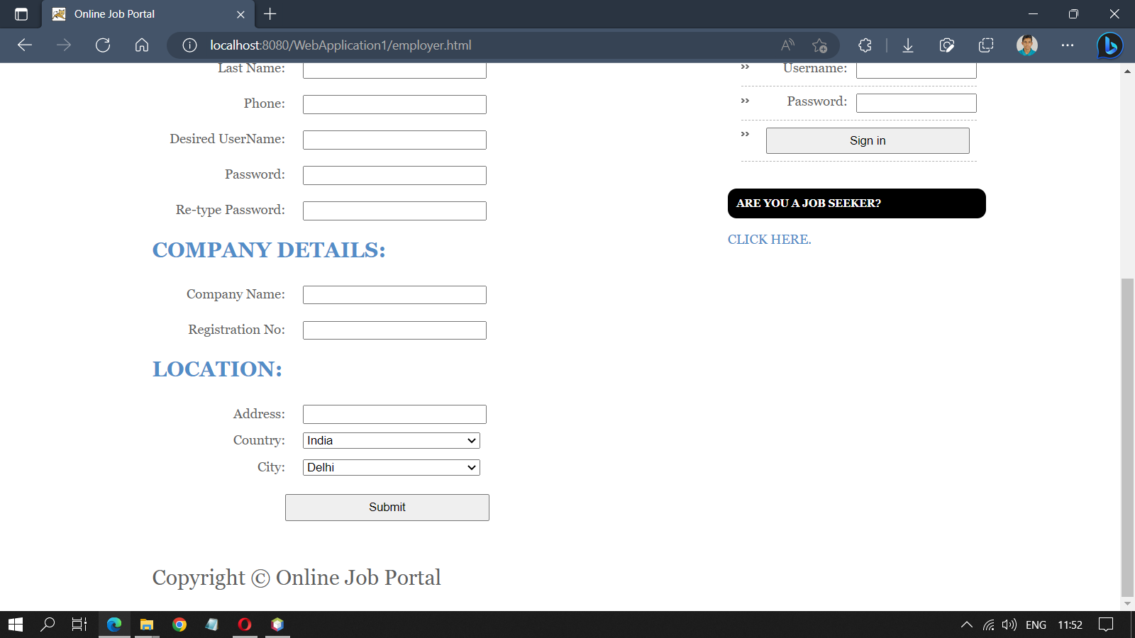

**Search:** This page allows employers to search for candidates by keywords such as job category and job skills. Employers can find suitable candidates for their job openings using the search function provided on this page.

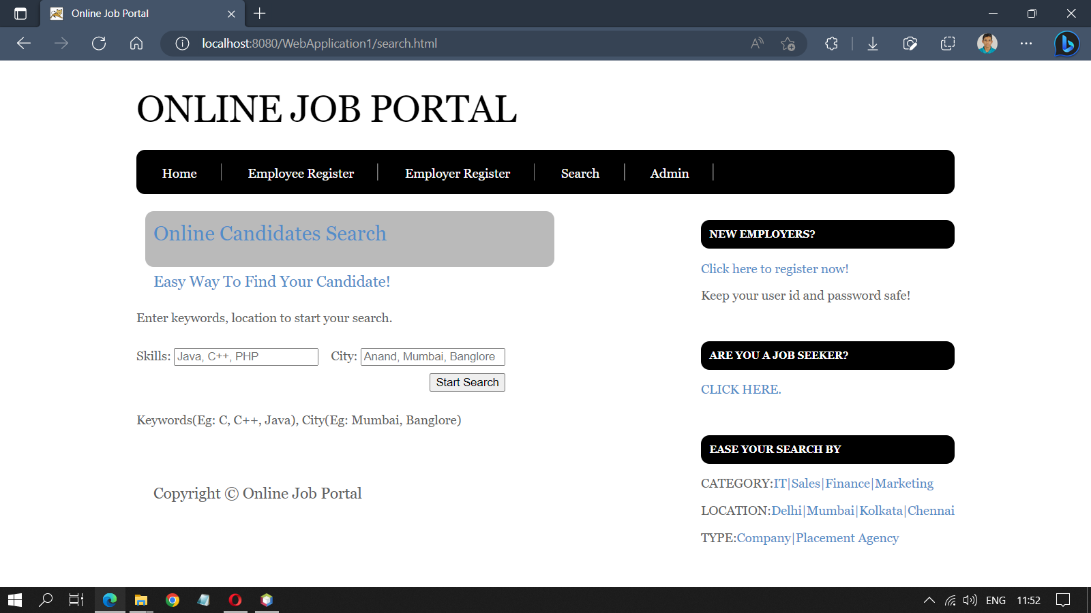

**Admin:** This is the login page that facilitates the login form for the admin.

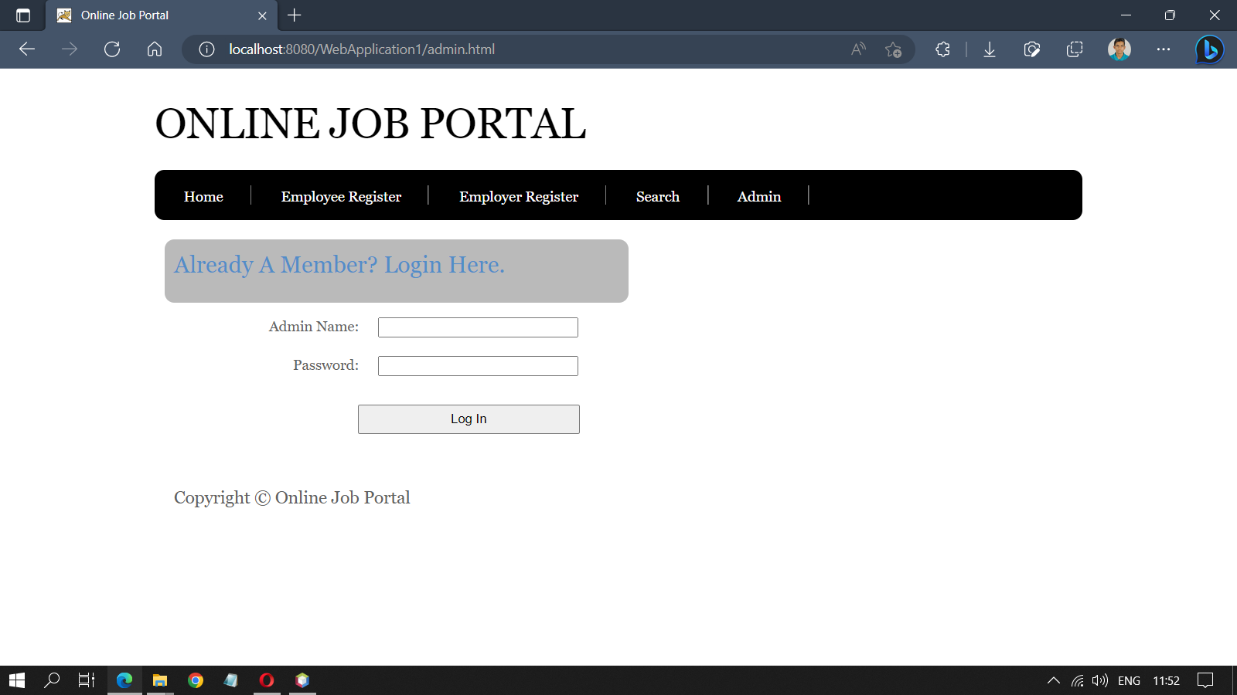

**Admin Profile:** This is the profile page of the admin. On this page, the admin can see the total number of employers, employees, and jobs. The admin can manage employers, employees, and jobs.

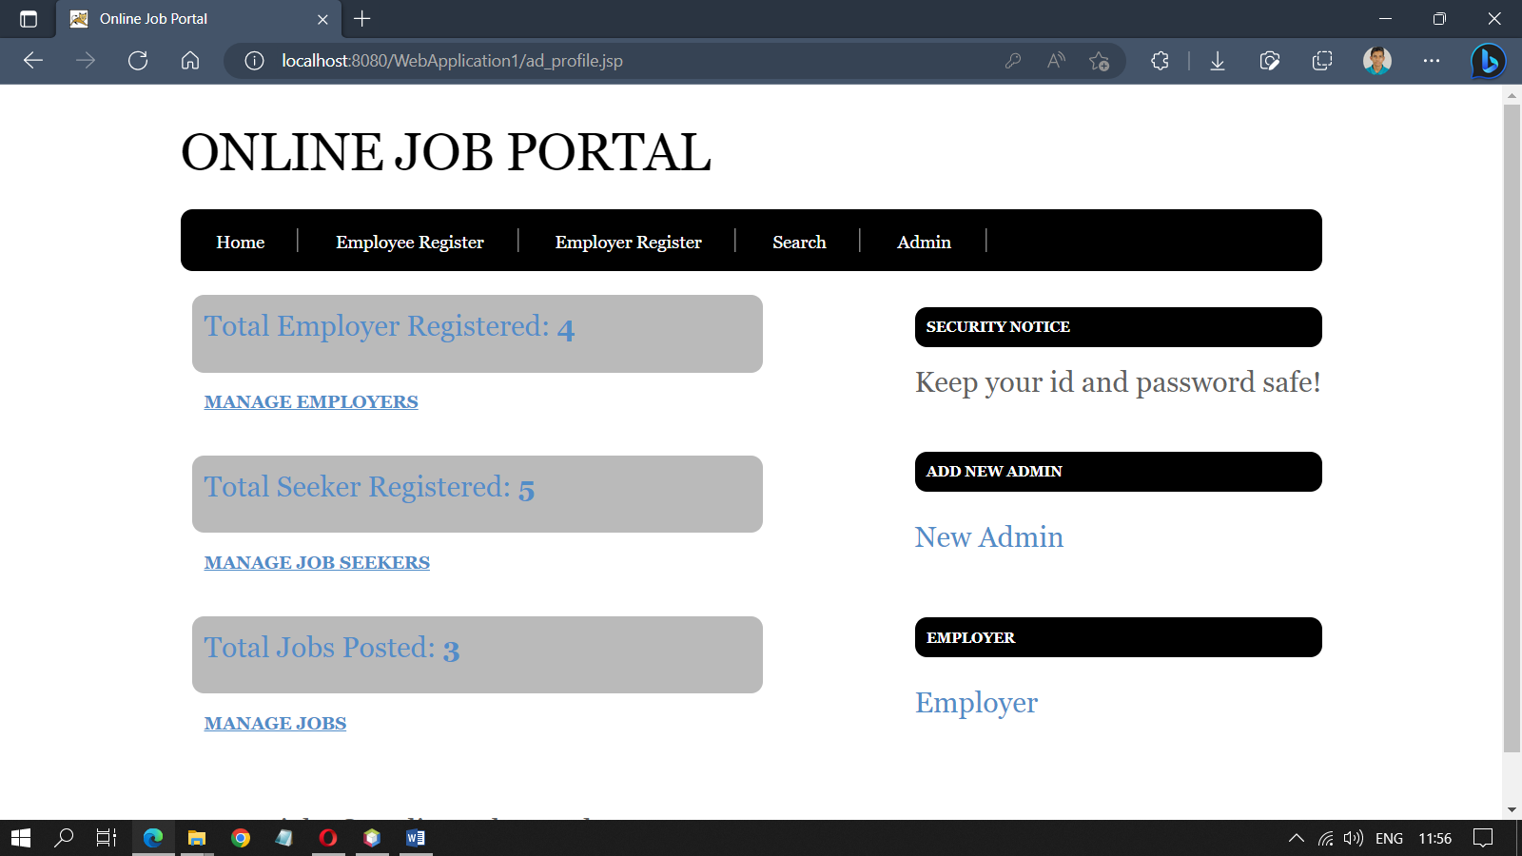

**Manage Employer:** On this page, the admin can search for employers using their ID and edit or delete their information.

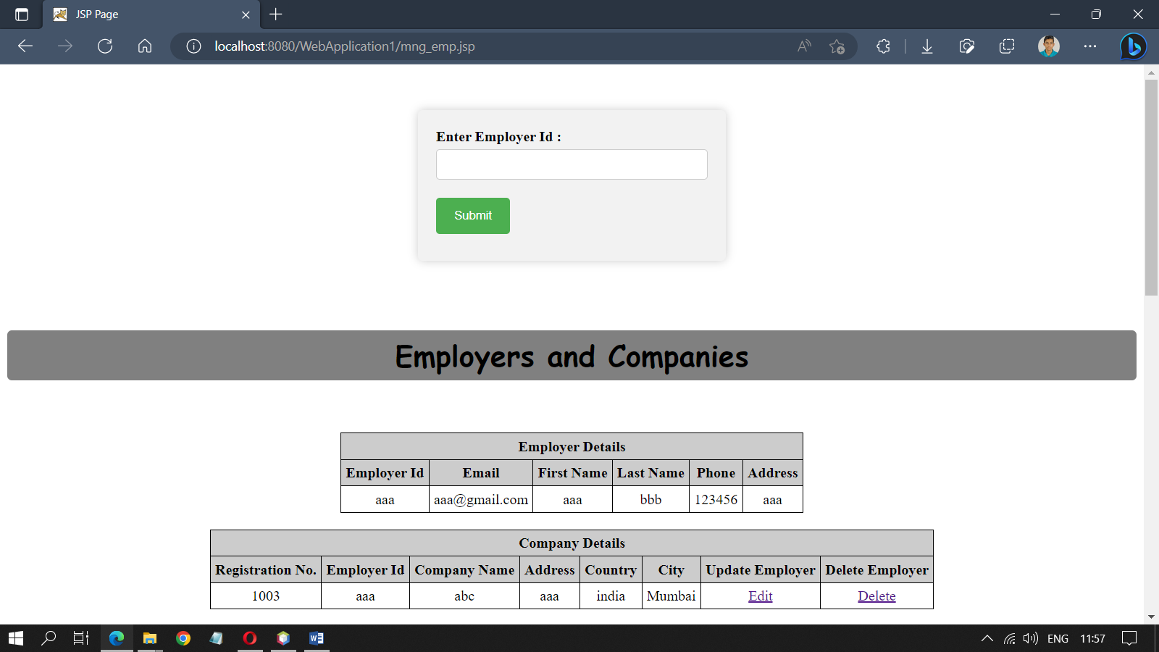

**Manage Employee:** On this page, the admin can search for employees by their ID and edit or delete their information as needed.

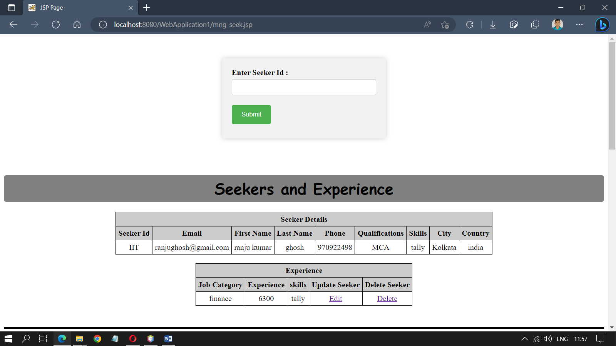

**Manage Jobs:** On this page, the admin can search for posted jobs by their ID and delete job information.

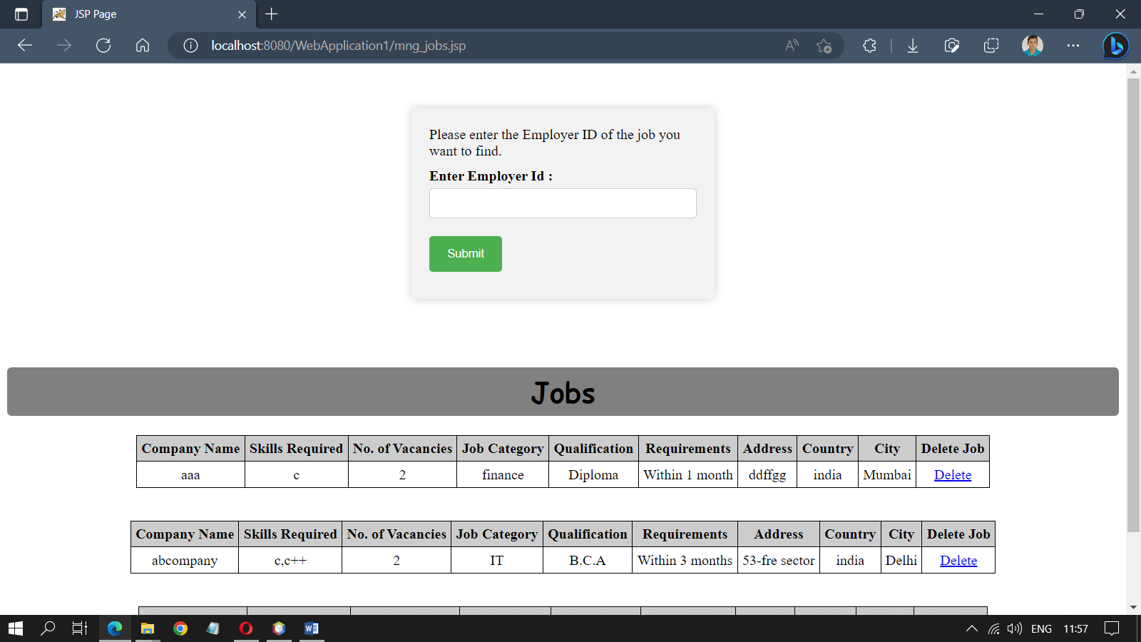

**New Admin Page:** This page allows an existing admin to add a new admin.

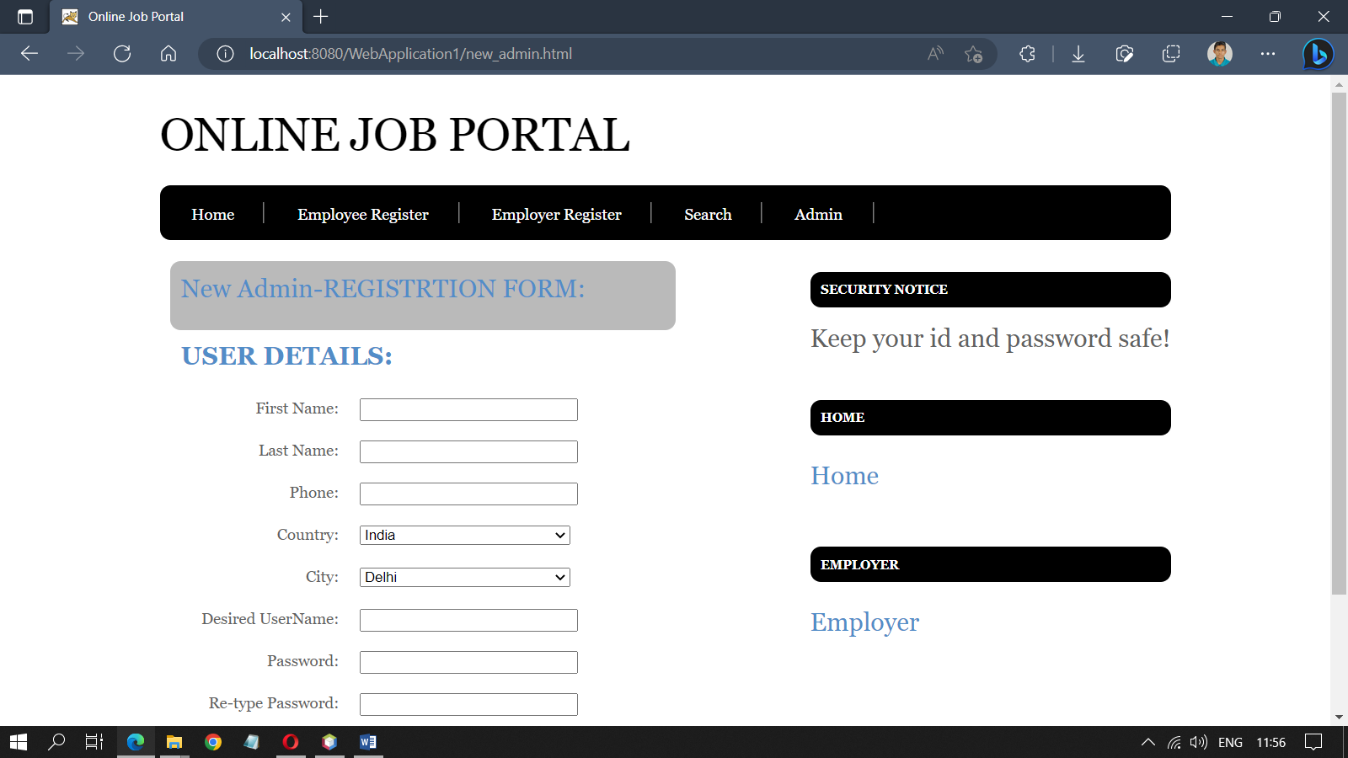

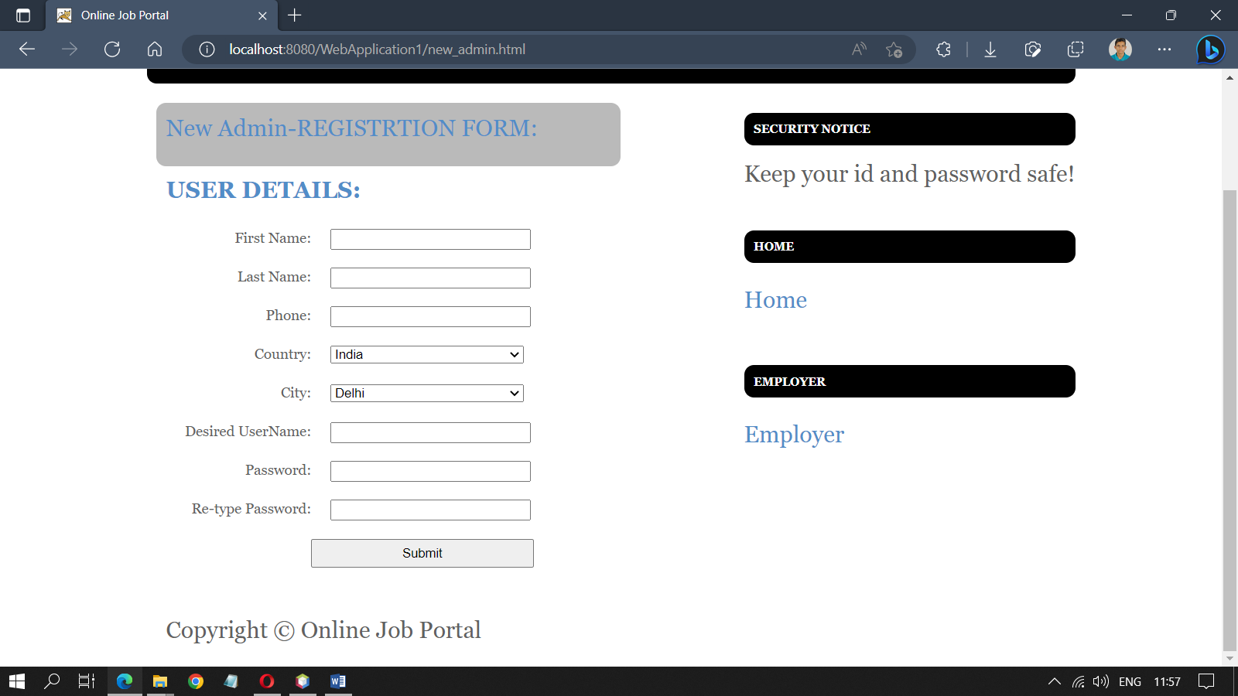

**Post Job:** On this page, the employer can post new jobs based on their requirements.

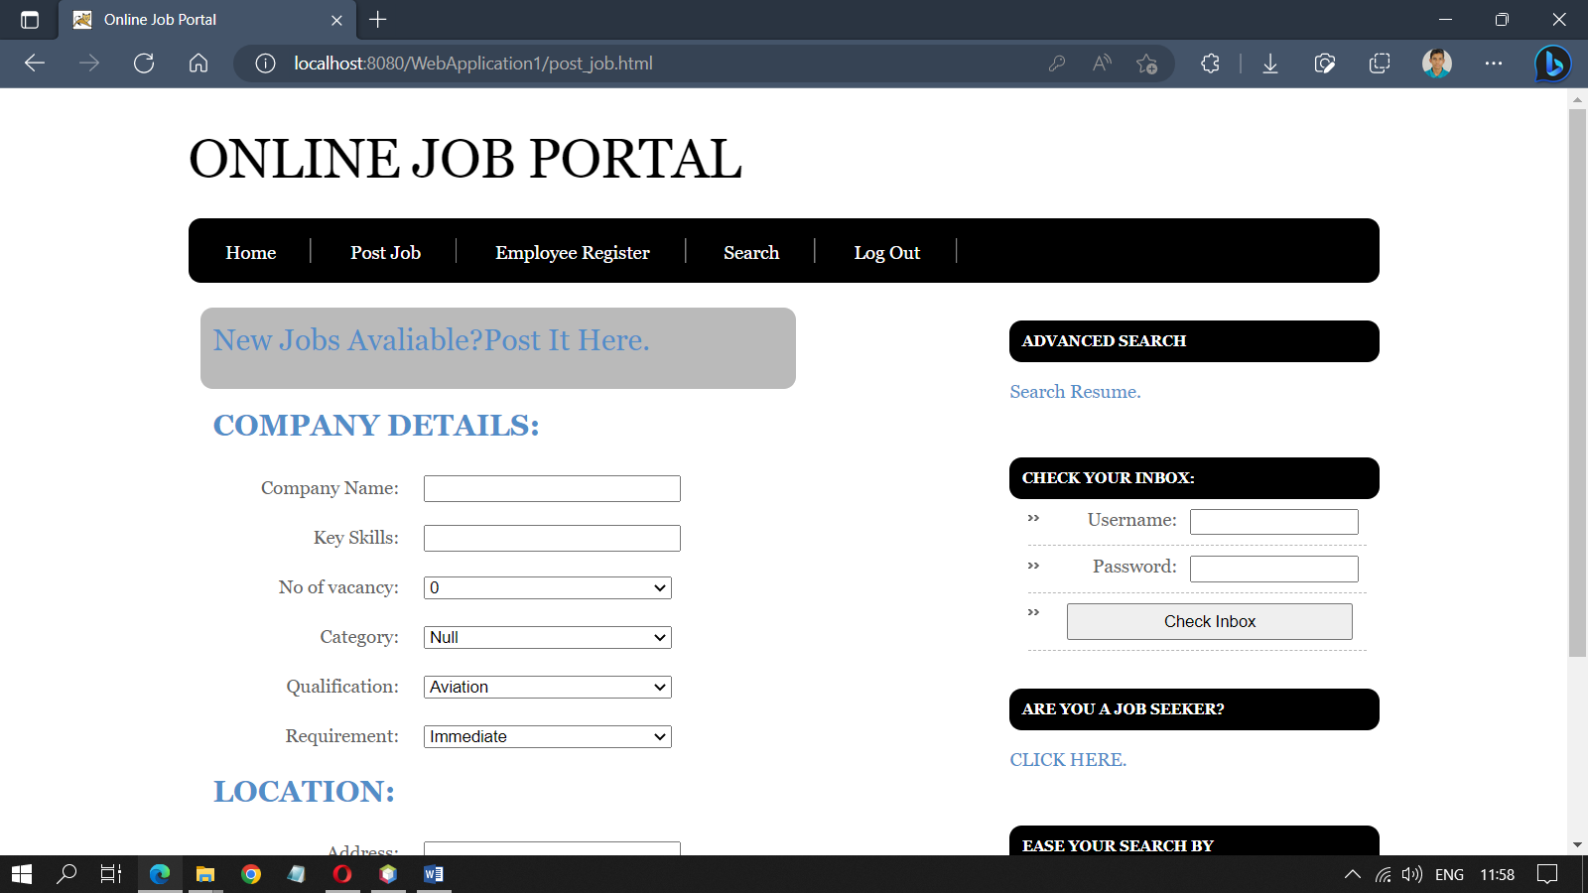

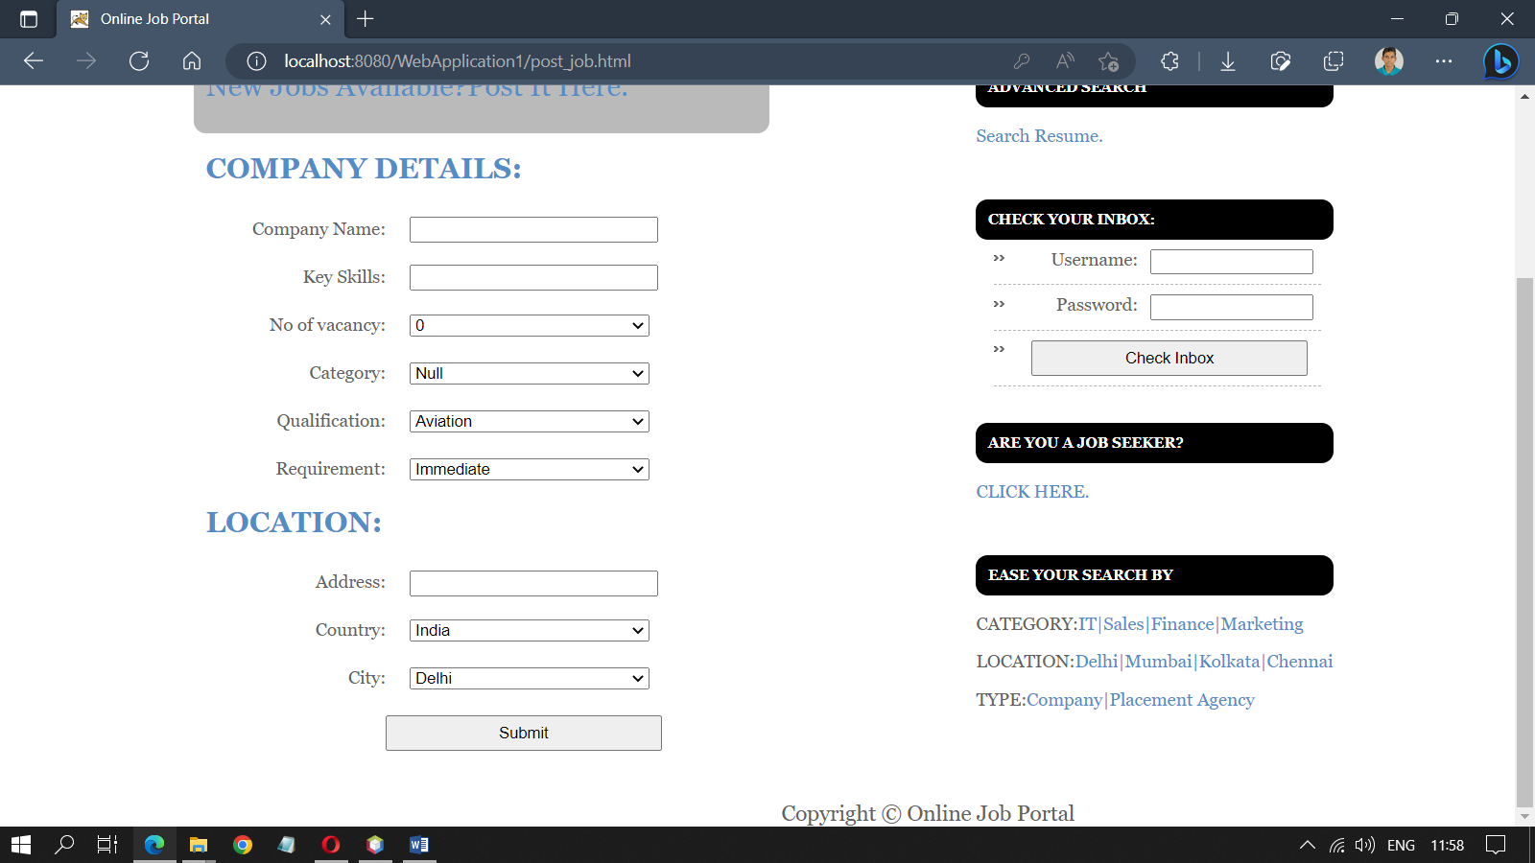

**Job Posted Page:** On this page, employers can view the jobs they have posted and edit the job details as needed.

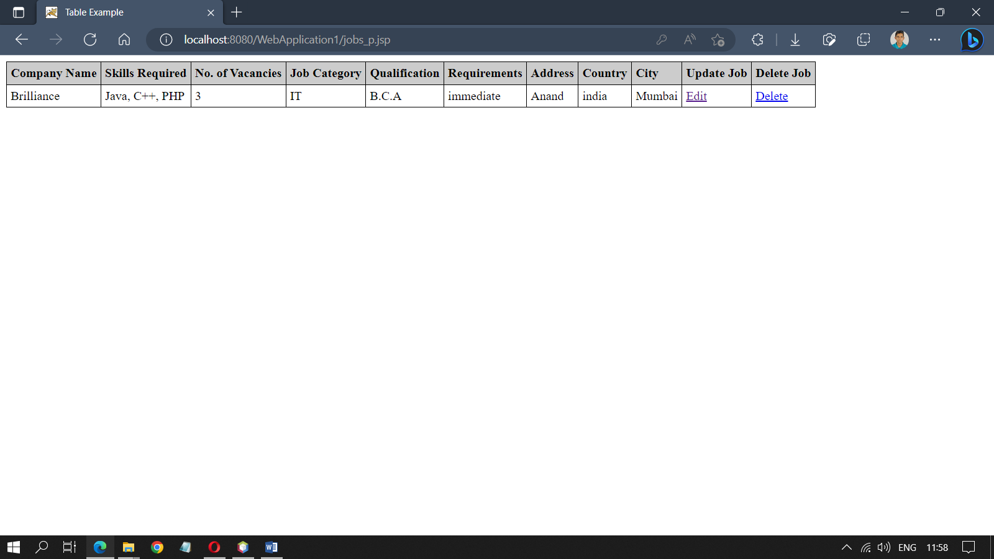

**Jobs Applied Page:** There are two Jobs Applied pages: one for the employer and one for the job seeker. The employer can view the list of candidates who have applied to the job, while the job seeker can view the list of jobs to which they have applied.

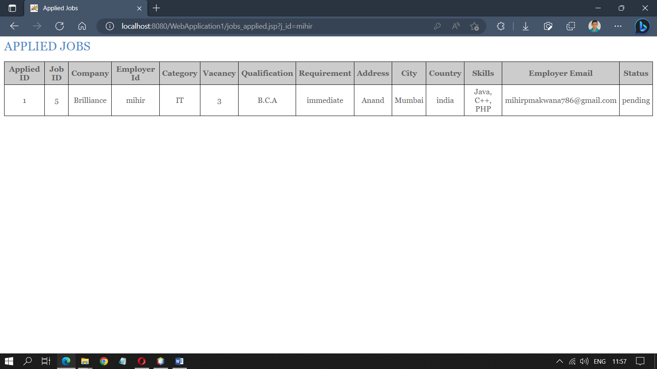

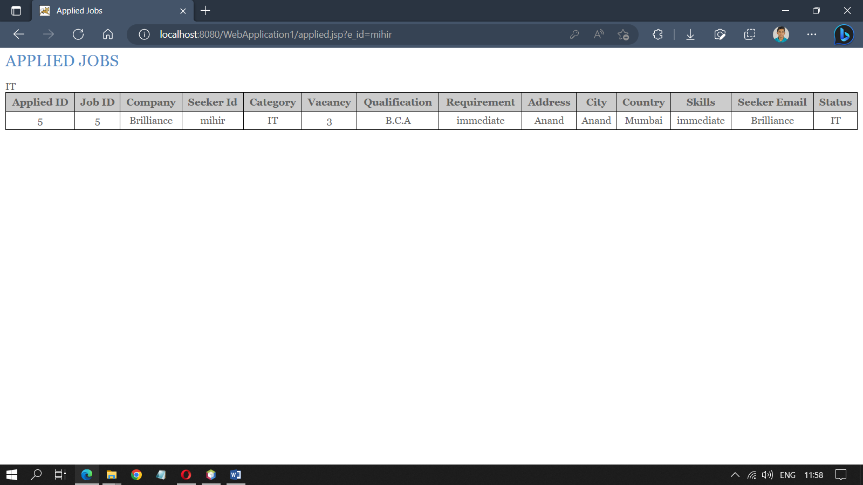

**Limitations**

1. Hardware and software requirements: The system has certain hardware and software requirements which may limit its accessibility to users who do not have the necessary equipment or software.
2. Security vulnerabilities: Despite efforts to ensure secure user registration and login, there may still be potential security vulnerabilities that could put user data at risk.
3. Limited scope: The system is designed to address specific limitations of existing job portals, but it may not cover all the possible features that users may want or need.
4. Limited testing: The system may not have undergone extensive testing in all possible scenarios, which could lead to unforeseen errors or issues.
5. Reliance on third-party services: The system may rely on third-party services such as web servers and databases, which could be subject to downtime or other issues outside of the project team's control.
6. User adoption: The success of the project may depend on user adoption and engagement, which could be difficult to predict or control.

**Conclusion**

In conclusion, the Online Job Portal project is a comprehensive solution that enables job seekers and job providers to connect with each other easily. The project includes various modules such as Admin, Job Seeker, Job Provider, Notification, Search, Report, and Authentication, which provide a user-friendly interface for users to navigate and interact with the system. The Admin module allows administrators to manage the system and maintain data integrity. Job seekers can register themselves, upload their resumes, and search for jobs based on various conditions using the Job Seeker module. Similarly, job providers can register themselves, post job vacancies, and search for job seekers based on their qualifications and skills using the Job Provider module. The Notification module allows administrators and job providers to send notifications to job seekers in the form of emails. The Report module generates various reports based on job seekers, job providers, and job vacancies, which can be accessed by the admin. The Search module, which was missing in the initial description, is also a crucial part of the project that allows job seekers and job providers to search for each other based on various criteria. The project has been developed using various software tools such as JDK 1.8, Java, JDBC, JSP, Servlets, HTML, CSS, Apache Tomcat 9.0, and MySQL. Overall, the Online Job Portal project provides a comprehensive platform for job seekers and job providers to interact with each other and fulfil their respective needs.

**BENEFITS:**

* The project offers several advantages to the users, such as being web-enabled and allowing data entry through simple and interactive forms.
* The system checks for data validity at every stage, preventing users from entering invalid data that could cause problems later.
* Users can update records, but primary data fields are restricted to maintain data validity.
* The project is user-friendly and provides easy navigation between options.
* The data storage and retrieval are systematic, making it faster and easier to maintain.
* The decision-making process is faster due to quicker information processing, and allocating sample results is also faster since users can access records from previous years.
* The latest technology ensures easier and faster data transfer, resulting in increased efficiency, accuracy, and transparency.

**Bibliography**

**Books Referred to:**

* Web Development with Java Server Pages - Duane K. Fields
* The Ultimate HTML Reference - Ian Lloyd
* HTML & XHTML: The complete reference, fourth edition – Thomas A. Powell
* Software Testing Techniques, Second Edition – Boris Beizer
* The Complete Reference Java2,Fifth Edition – Herbert Schildt
* Software Engineering Tata McGraw-Hill-Rogers. Pressman
* JDBC Specification Sun Microsystems-
* Core Servlets and JSP Sun Microsystem- Marty Hall
* JAVA2 complete reference BPP- Herbert Schildt

**Web references:**

* [www.wikipedia.org](http://www.wikipedia.org)
* [www.w3schools.com](http://www.w3schools.com)
* [www.suncertification.com](http://www.suncertification.com/)
* [www.wiley.com](http://www.wiley.com/)
* [www.wrox.com](http://www.wrox.com/)
* [www.sun.java.com](http://www.sun.java.com/)
* [www.ignou.ac.in](http://www.ignou.ac.in/)
* [www.minddt.com](http://www.minddt.com/)
* [www.plannet.source.com](http://www.plannet.source.com/)
* [www.jakrta.com](http://www.jakrta.com/)